Modeling of boxer engine
A flat engine is an internal combustion engine with horizontally-opposed pistons. The cylinders are arranged in two banks on either side of a single crankshaft and are otherwise known as the boxer engine, or horizontally-opposed engine. Each cylinder has two pistons but no cylinder head and is 90 degrees to the horizontal plane.
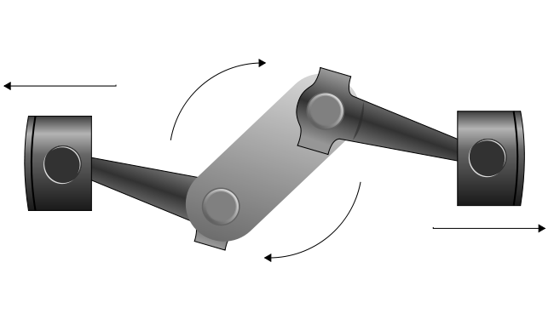
In this paper we study the working and generate the model parts like piston, crank shaft, connecting rods etc., and assembled the parts of boxer engine in solid works premium 2014.

